

Puglia, Italy’s Enchanted South: A Journey of Biking, Hiking & Culture
April 2027

THIS IS A POSSIBLE PROSPECTUS AND IS NOT YET APPROVED. PLEASE EMAIL US DEEDICE29@GMAIL.COM TO SHOW YOUR INTEREST.

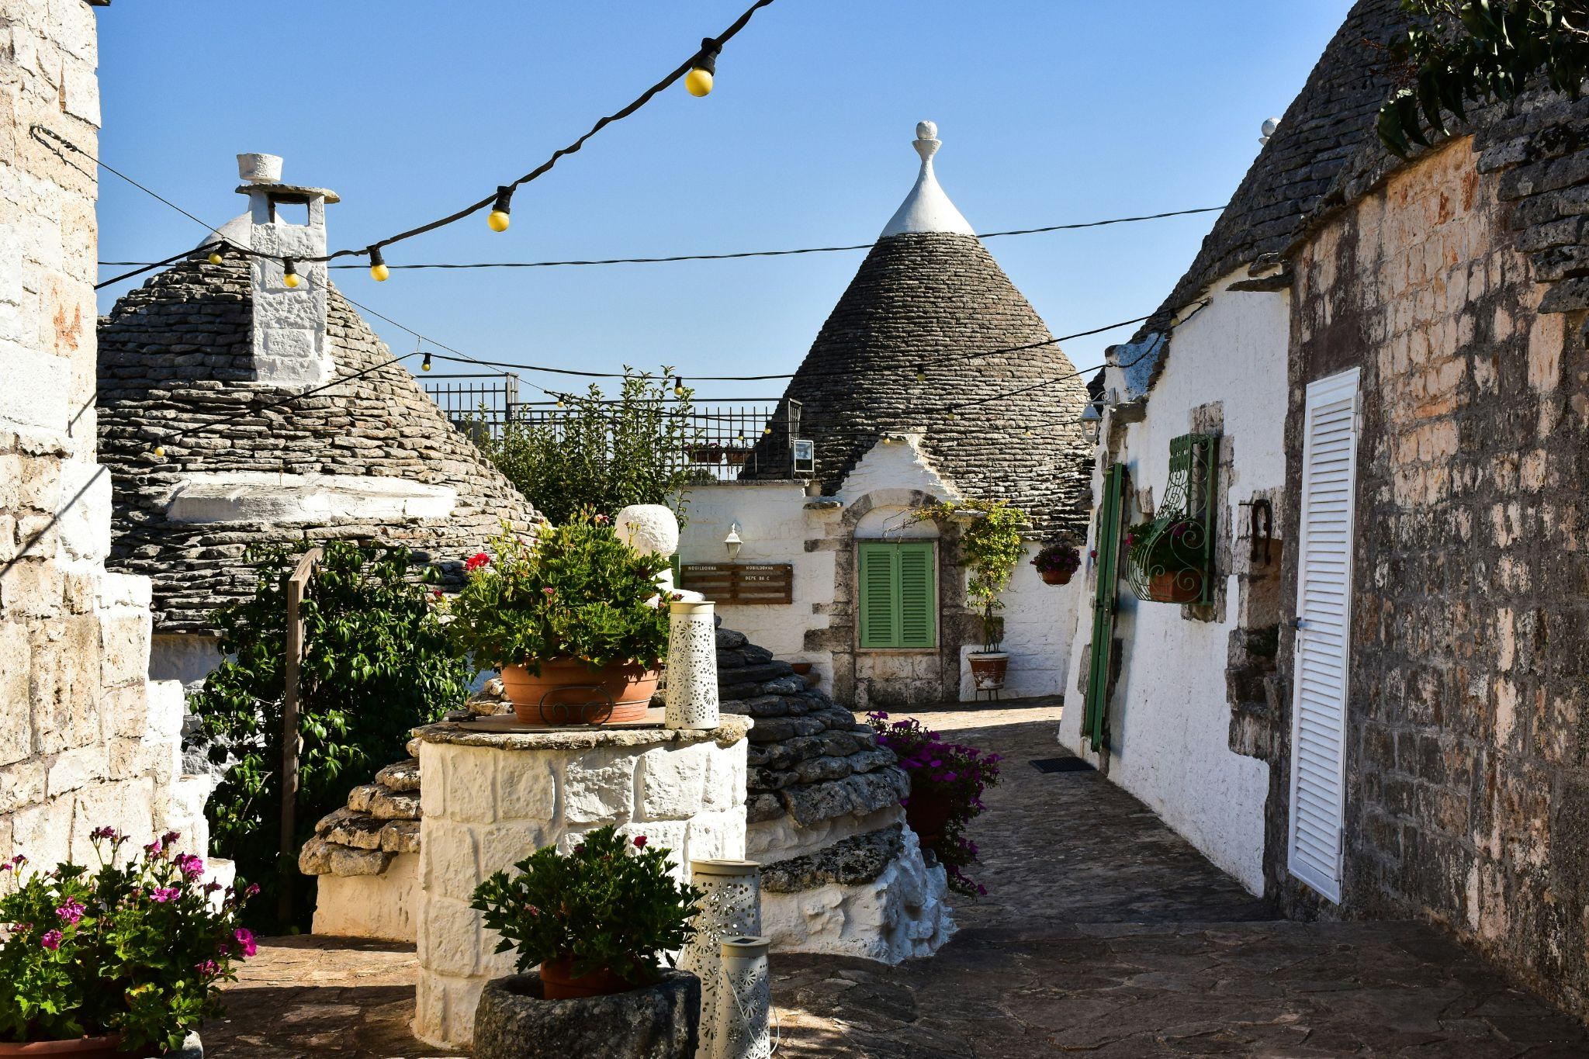
(Alberobello, Italy Photo by AXP Photography on Unsplash)

Trip Overview
Step back in time and immerse yourself in the other worldly charm of Puglia, Italy. Nestled between the Adriatic and Ionian seas, this region is rich in history from the Norman to the Byzantine. It offers a unique blend of culture, adventure, and stunning landscapes. Cycle along the rugged coastline and peaceful "white roads," and hike through picturesque villages perched on dramatic cliffs overlooking the sea.
Your 10 day journey begins in Matera, a UNESCO World Heritage site, where you will hike beside caves and a gorge with breathtaking views. Our group will cycle to the world-famous Alberobello, in the Valle d’Itria, where we will explore rolling hills, quaint villages, and iconic trulli architecture. You will cycle along the "Ciclovia dell' Acquedotto Pugliese," a scenic bike path that follows the route of the Apulian Aqueduct. A highlight will be a coastal hike from Monopoli to Polignano a Mare, a town perched high on the cliffs.
We will then travel to Lecce, the “Florence of the South,” which boasts Baroque architecture, a Roman amphitheater, and an artisanal ambiance. Conclude your adventure in Otranto, an ancient walled city, from which you will cycle to the southern tip of Puglia as well as enjoy a hands-on cooking class. From ancient history to modern-day indulgence, this trip offers an unforgettable blend of exploration, culture, and variety.
Highlights of the trip:

- Enjoy the delicious, unique cuisine of Puglia.
- Explore the UNESCO World Heritage site of Matera, with ancient caves and breathtaking views.
- Cycle through the Valle d’Itria to our lodging in the iconic trulli village of Alberobello.
- Bike on the "Ciclovia dell' Acquedotto Pugliese" a path along an ancient aqueduct throughout Puglia.
- Hike through picturesque villages and dramatic cliffside paths overlooking the sea.
- Visit a marine reserve dedicated to saving the “Caretta Caretta” turtle.
- Discover Lecce’s Baroque architecture and colorful history.
- Enjoy an olive oil tasting at a masseria, plus a hands-on cooking class with local ingredients.
- Cycle to the walled city of Otranto and ride down the coast to the southern tip of Puglia

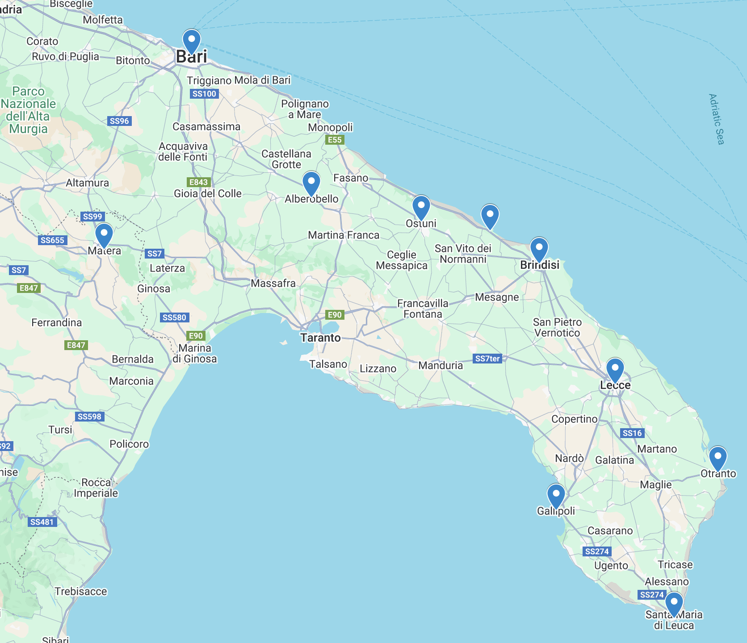
Map of our Journey through Puglia, Italy
Trip Difficulty
This trip is rated Moderate.
AMC Trip Rating
This trip is suitable for participants who can comfortably cycle 20 -36 miles in a day. The terrain will be either mixed terrain “white roads” or asphalt. Two of the rides will have elevation gains of 300’ and 900’ respectively, while one route will have a gain of 1400’ over 36 miles. Speed will be a moderate 11- 13 mph on rolling terrain and slower on white roads and hills. Our hiking routes will also be of moderate distance and pace (ranging from 3-7 miles) and have elevation gains from 337’ to 800’. Our relaxed pace will allow ample time for photo stops and sightseeing.
Daily Itinerary

It is recommended that Participants arrive in Italy by March 19th in order to acclimate to the time change before starting our journey. Participants will either fly directly to Bari or into Rome and take a train to Bari. We will meet mid-day in Bari on Day 1.
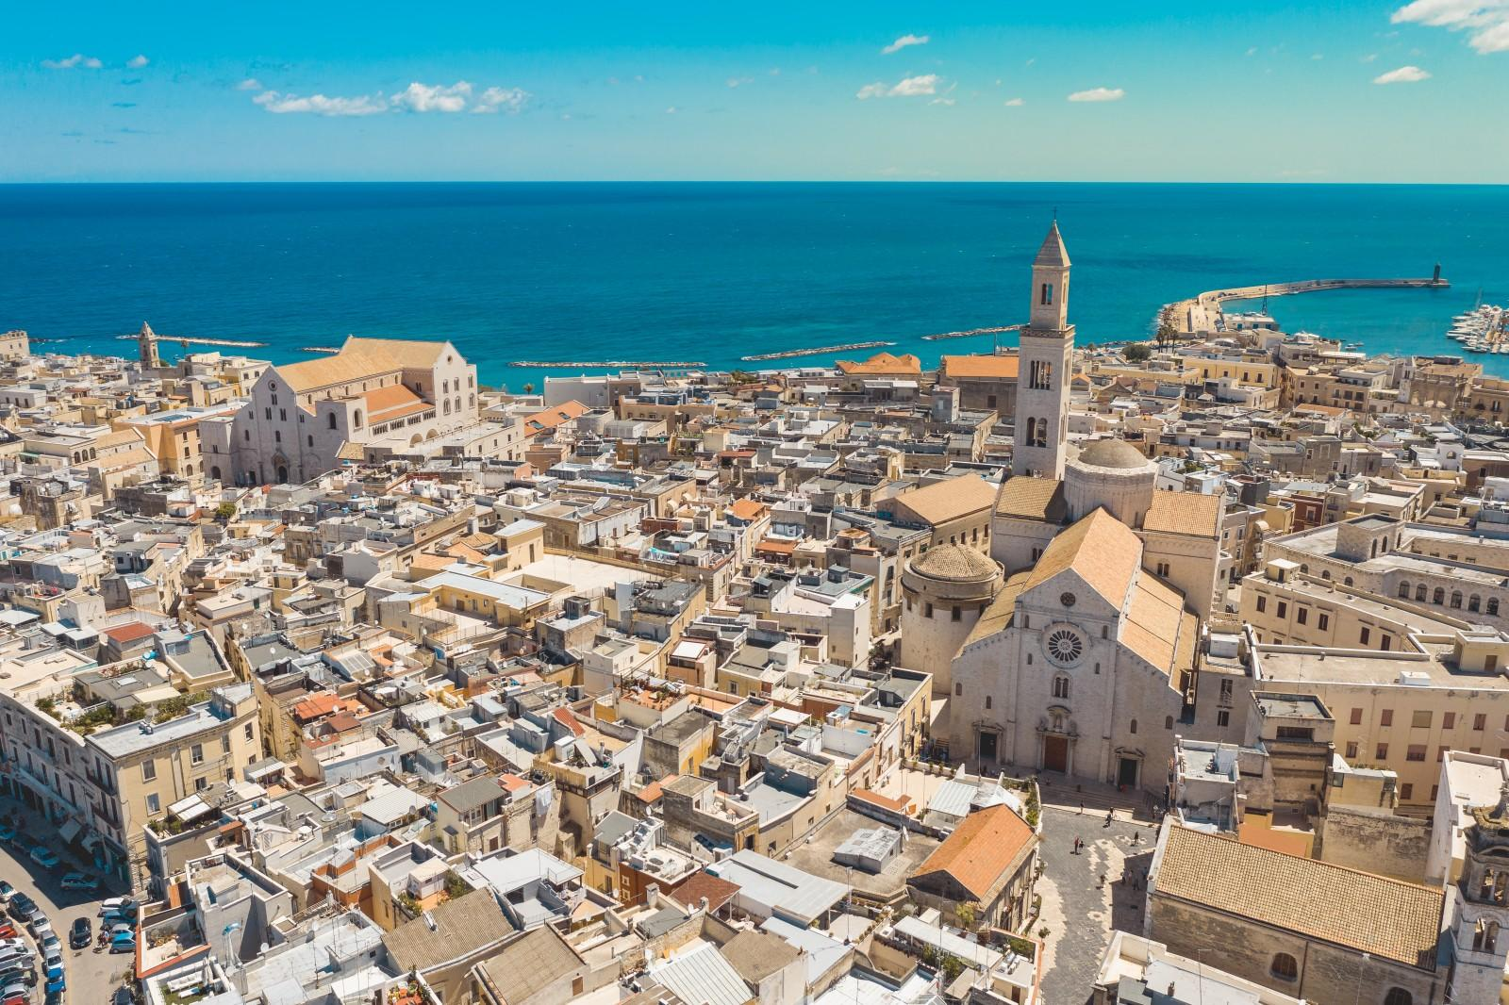
(Bari, Italy Photo by Southern Visions Travel)
Day 1
Upon arrival in Puglia, our group will gather at the Bari train station and share a delicious lunch in a local restaurant. We will then enjoy a walking tour of Bari, Puglia's prosperous seaside capital, with an expert guide. We will stroll the tangled streets and charming old town to discover the spacious medieval piazzas and beautiful San Nicola Basilica, home of Saint Nicholas, the father of the legend of Santa Claus. At the end of the tour, we will be driven to our hotel in Matera. We will enjoy a free evening in Matera.
Overnight in Matera (-/L/D)
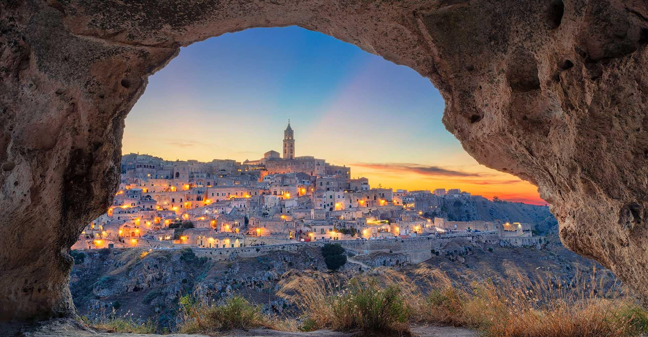
(Matera Italy, Photo by Southern Visions Travel)
Day 2
This morning we will hike from town, across a hanging Tibetan bridge, to explore Murgia Materana Park (3-5 miles, 800’ elev. gain). The exact distance will be determined by the leaders at the time. The park’s historic, rugged landscape is filled with ancient caves and stunning panoramas of the town. After lunch on our own, we will enjoy a walking tour of Matera, an ancient city perched high on a beautiful hillside, and only recently seen by foreign eyes. This famed UNESCO World Heritage Site is in the Basilicata Region, just across the border from Puglia. A number of recent blockbuster movies have been set in Matera, including the latest 007 movie “No Time to Die.” Our local guide will treat us to a tour of the “sassi,” ancient cave dwellings which have been restored for current use as homes, shops and restaurants. Tonight, we will enjoy a delicious dinner based on regional recipes.
Overnight in Matera (B/-/D)
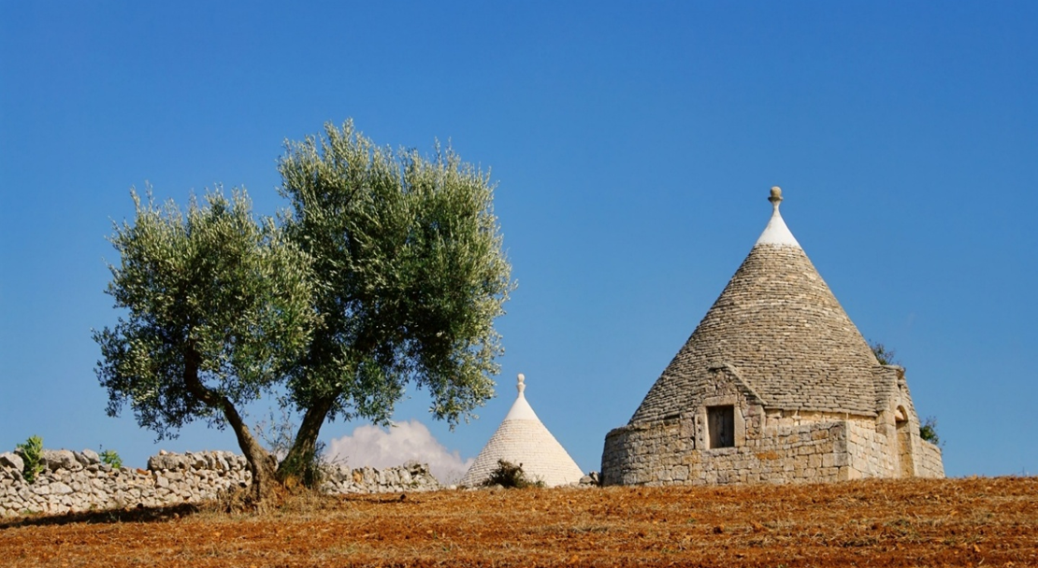
(Alberobello, Italy Photo by Southern Visions Travel)
Day 3
Today will be our first day of great riding! Our bike company expert will meet us at the hotel and hold a dedicated bike fitting. We will ride out of the rugged scenery of the Materana Murgia and reach the green scenery approaching the Itria Valley. This adventure will bring us to the UNESCO World Heritage Site of Alberobello, the postcard capital of the region (approximately 36 miles, 900’ elevation gain). Upon arrival, we will check-in at our hotel and have free time for lunch. In the afternoon, our group will enjoy a walking experience in town with a local guide. In Alberobello, the streets are lined with trulli houses: dry-stone houses with conical roofs that dot the landscape by the hundreds. These unique houses are surprisingly ingenious structures, complete with their own rainwater collection and storage. We will stroll along the picturesque winding alleys and step into another world, full of folklore and traditions. In the evening, we will enjoy a well-deserved dinner at one of the best restaurants in town. Overnight in Alberobello (B/-/D)

Day 4
This day’s bike route starts in Alberobello and reaches the bicycle path of the aqueduct of Puglia, crossing canal bridges, oak forests and exploring the trulli architecture surrounded by nature (approximately 30 miles, minimal elevation gain). The "Apulian Aqueduct Cycle Path" or "Ciclovia dell' Acquedotto Pugliese" is a scenic cycling path that follows the route of the Apulian Aqueduct. This is an ancient aqueduct system that was constructed to transport water from the source to various towns and cities in the region. In every season, the cycle path of the Apulian Aqueduct allows you to admire the landscape of the Valle d'Itria. Back in town, we will have a free afternoon to get to know Alberobello. In the evening, we will be transferred to Cisternino for dinner. Here we will have a very traditional experience at one of the many butcher shops, also known as Fornelli Pronti (literally "ready ovens"). After selecting the meat, it will be grilled on the spot directly at the butcher!
Overnight in Alberobello (B/-/D)
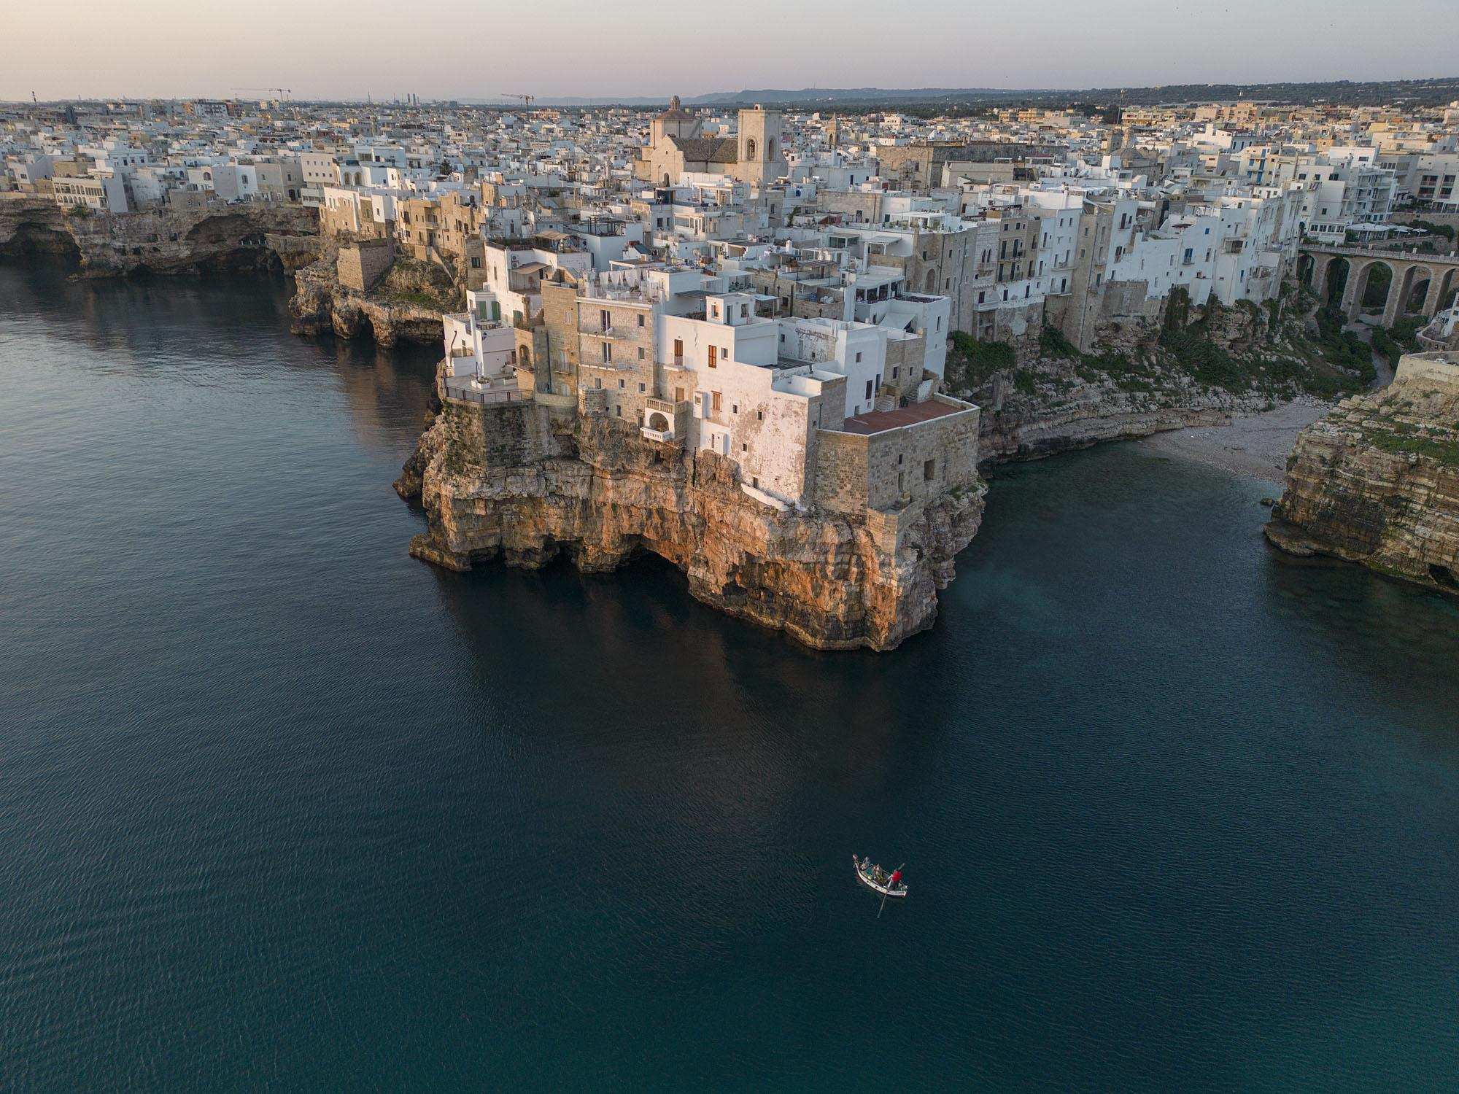
(Polignano a Mare, Italy Photo by Southern Visions Travel)
Day 5
We will be transported in the morning to our 3-5 mile hike (335’ elevation gain), starting near Monopoli and heading to the striking cliff-top town of Polignano a Mare (which hosts the annual Red Bull Cliff Diving Championship). When we arrive, we will have free time to explore the town of Polignano. After a delicious fish lunch, we will be transferred to Ostuni, known as the “White City.” Gothic, Romanesque and Byzantine history abound in the old town of this beautiful gem. We will check into our hotel and explore Ostuni with dinner on our own.
Overnight in Ostuni (B/L/-)

Day 6
Today we will experience first-hand one of Puglia's most important treasures: olive oil! We will travel to a renowned Masseria, or farmhouse estate. We'll walk the beautiful grounds of the estate, explore the olive oil production process, enjoy some olive oil tasting and an unforgettable lunch. Then we will be transferred to the Natural Reserve of Torre Guaceto. We will discover the local flora and fauna in this protected marine nature reserve with our expert environmental guide. We will learn about the project to safeguard the "Caretta Caretta" turtle as well as the history of this famous coastal area. This 2-3 mile walk is easy, with no elevation gain. At the end of our tour, we will check into our next hotel in Lecce and have dinner on our own.
Overnight in Lecce (B/L/-)
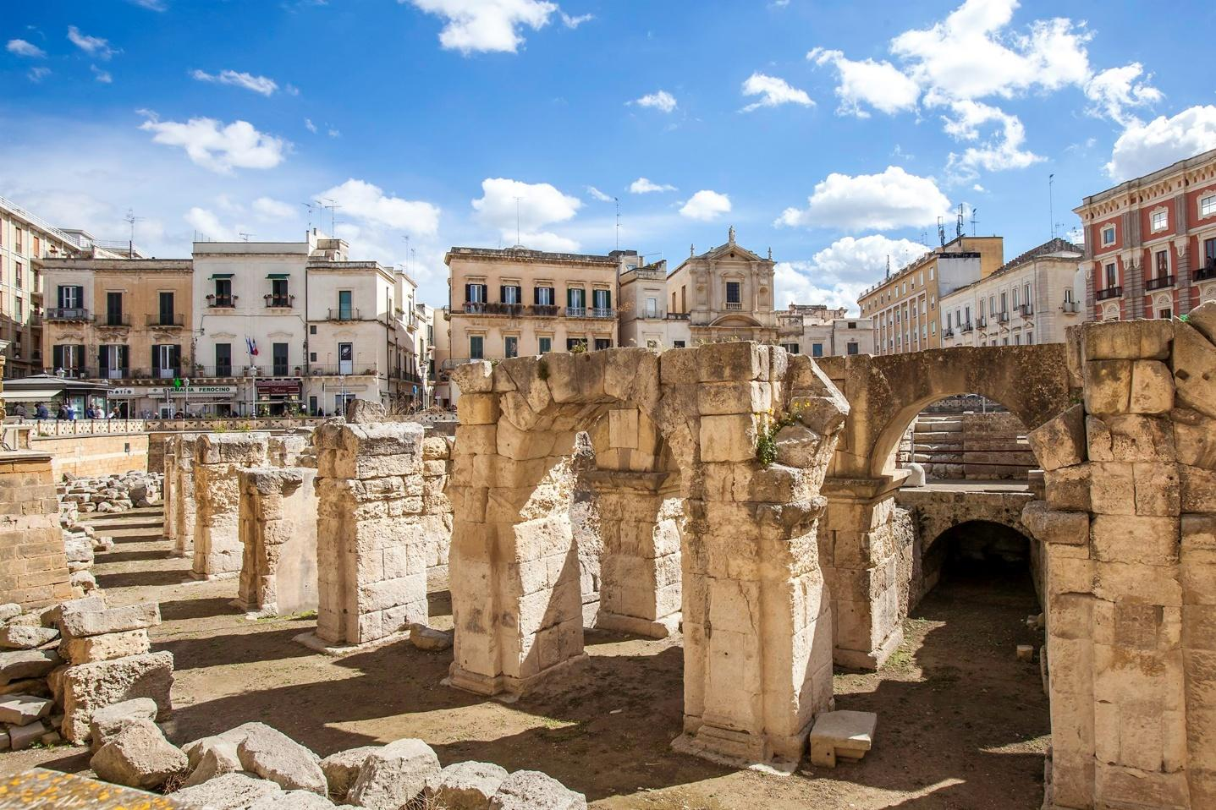
(Lecce, Italy Photo by Southern Visions Travel)
Day 7
Today we will hike in Porto Selvaggio, a Regional Natural Reserve located on the Ionian coast, just 20 km north of Gallipoli (4-7 miles, approximately 400’ elevation gain). We will be delighted to find archaeological and paleontological treasures, rare plants and beautiful coastal towers, but above all, breathtaking panoramas which make Porto Selvaggio one of the most fascinating Natural Reserves in Puglia. Distance will be determined by the leaders at the time, as there are many route options. We will return to Lecce for lunch on our own. We will explore Lecce in the afternoon, with a local guide, to experience a city brimming with impressive sites and a vibrant artisanal scene. Dinner will be a special treat, as local chef Gianna will share secrets of the region's culinary traditions during our cooking class, where we will make a delicious 4-course dinner.
Overnight in Lecce (B/-/D)
Day 8
This morning we will be transported to the medieval village of Acaya, to begin our cycling route to our next accommodation (approximately 20 miles 300’ elevation gain). Our destination on the Adriatic coastline will be Otranto, one of Italy's most beautiful ancient walled cities. We will check into our hotel and explore the town’s labyrinthine streets and alleyways. In the evening we will enjoy a delicious dinner at one of the nicest restaurants in town.
Overnight in Otranto (B/-/D)
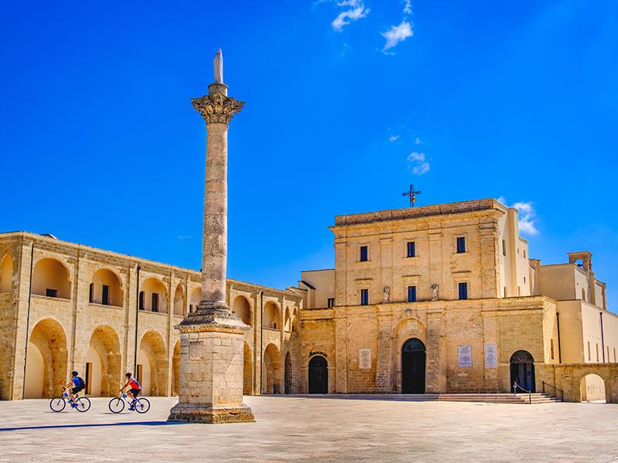
(Santa Maria di Leuca, Italy Photo by Southern Visions Travel)
Day 9
Today we will embark on a glorious 32-mile ride from Otranto to Santa Maria di Leuca, a picturesque town at the heel of Italy (1440’ elevation gain). The name Leuca derives from the Greek "leukos", meaning white city kissed by the shining sun. Breathtaking sea views, natural hot springs, hills, and pine forests make this one of the most memorable rides on the trip. We will stop along the way for a light lunch (not included). From Leuca, we will return back to the hotel by van for a free afternoon in Otranto. In the evening, we'll be treated to a wonderful restaurant outside of town for a memorable farewell dinner!
Overnight in Otranto (B/-/D)

Day 10
After check-out and breakfast, everyone will be transported to Brindisi airport or train station to continue their journey or return home. (B)
Accommodations, Meals and Transportation
We will be staying in 3 and 4-star hotels in Matera, Alberobello, Ostuni, Lecce, and Otranto, all with double occupancy. Our accommodations will boast modern amenities within historic settings. Each hotel will be conveniently located in or near the town center, allowing us to walk to restaurants, shops, and activities. We will be hiking directly from our hotel in Matera, and cycling from our accommodations in Matera, Alberobello, and Otranto. Transportation will be in 2 Mercedes 8-seat vans on 9 breakfasts, 3 lunches and 6 dinners are included.

What to Bring
A packing list will be provided in the first trip newsletter.
The Weather
The average temperature in Puglia in March is 13°C (56°F), with an average range of 50-64 degrees F. Mornings and evenings will be cool, while mid-day will be quite moderate - perfect hiking and biking weather! March is a time of transition, where the days are longer and the sun is climbing higher in the sky than in the winter. There is some chance of rain, approximately 8 days/month.

Trip Price
The AMC Member price is x The non-member price is x
To join the AMC click here. (The 2025 membership price is $50 individual, $75 family)

The trip fee includes the following:
- 9 nights lodging in 3 and 4 star hotels. Double Occupancy. 2 nights in Matera, 2 nights in Alberobello, 1 night in Ostuni, 2 nights in Lecce, and 2 nights in Otranto
- 9 breakfasts
- 3 lunches (including on arrival in Bari, a fish meal in Polignano a Mare, and an olive oil tasting at a masseria near Ostuni)
- 6 dinners, including a hands-on cooking class in Lecce
- Bike Rentals (high end road bikes, hybrid bikes, or e-bikes)
- Guided tours of towns (Bari, Matera, Alberobello, and Lecce)
- Guided tour of Torre Guaceto Park
- National park entrance fee
- Tips for our guides and drivers
- All ground and luggage transportation
- Emergency medical and evacuation insurance
The trip fee does not include the following:
- Airfare to Rome or Bari (Estimate $900 - $1400 from major East Coast cities). Leaders will provide guidance for booking air travel.
- Round trip fast train tickets from Rome to Bari and Brindisi to Rome (Estimate $140pp).
- 6 lunches (on Days 2,3,4,7,8,9)
- 3 dinners (on Days 1,5,6)
- Alcoholic beverages
- Insurance for travel delay, interruption, cancellation, or for baggage loss

While participant airfare and ground transportation are not included in the trip price, leaders may assist participants in making suitable reservations. At a minimum, participants will be told when and where they must join the group for the official start of the trip’s planned activities. Once your air tickets are purchased, they are your responsibility – do not make any non-refundable travel plans until told to do so by the leaders.

Participant Expectations
Participant Expectations: This is a group activity and we will be spending many, but not all, hours together. We expect that everyone will pitch in and contribute to helping each other have a great time.
Application Process
We expect a group size of 14 people, plus the 2 leaders. This trip is likely to fill quickly.
To show your interest in the trip, please email Dee @ deedice29@gmail.com

Terms, Conditions and General Information
Until the trip is confirmed to run on schedule, you may cancel with a full refund of your trip deposit. Please review the full AMC-AT cancellation policy found in this document: AMC Adventure Travel Standard Terms and Conditions. By applying for this trip, you agree to the provisions of the AMC-AT Terms & Conditions, including that you have read and understand the stated Trip Cancellation Policy. You are welcome to contact the leaders with any questions you have about this policy before you submit your application.

Trip Leaders
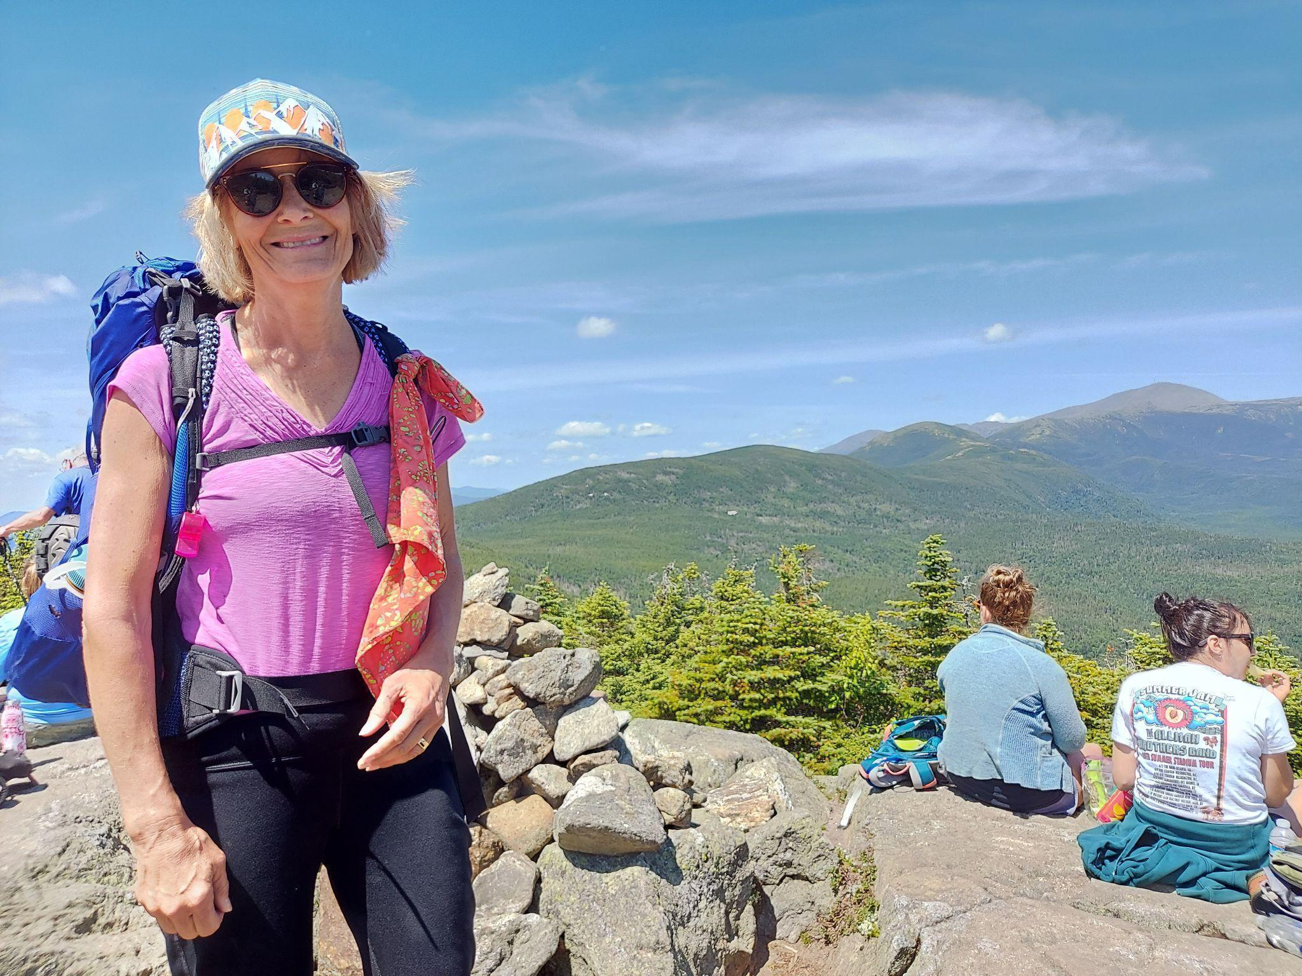
Sue Christopherson
Sue is a psychologist who has led Mindfulness- based retreats in wilderness settings. She is certified by the School of Outdoor Mindful Leadership at the Kripalu Center for Yoga and Health. As an avid hiker and cyclist, she has traveled throughout Europe and the US. She led many friend groups on outdoor adventures in Midcoast Maine. She began leading weekend trips in New England with the Boston Chapter of the AMC in 2019 and is thrilled to be leading Adventure Travel Trips in the US and abroad. chrstphrsn9@gmail.com
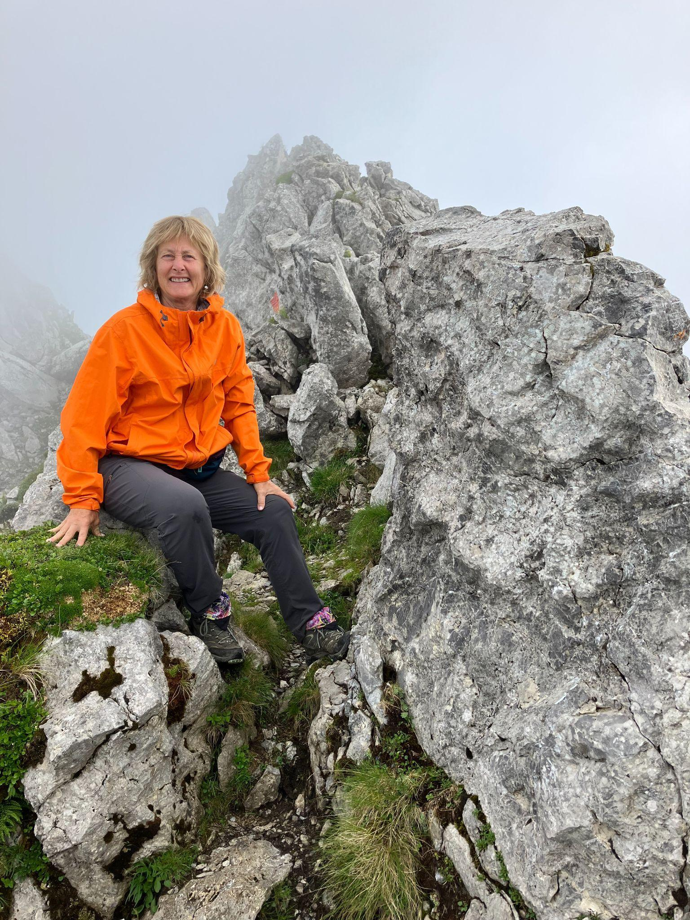
Dee Dice
Dee is an Adventure Travel Leader who has led trips in Glacier National Park, Baja Mexico, Spain, Morocco, and a two-week hiking trip to Austria. She has been leading hikes, weekend trips, and paddling trips with the AMC Western Mass and Worcester Chapters since 2018. Her passion is hiking and kayaking which has taken her around the world, traveling extensively to Nepal, New Zealand, South America, and Europe. deedice29@gmail.com 508-566-9565

